# Wi-Fi module setup

* Connect both antennas to the WiFi adapter.
* Power-up the adapter.
* Connect to the "AirborneAP" network. WiFi create this access point using default configuration:

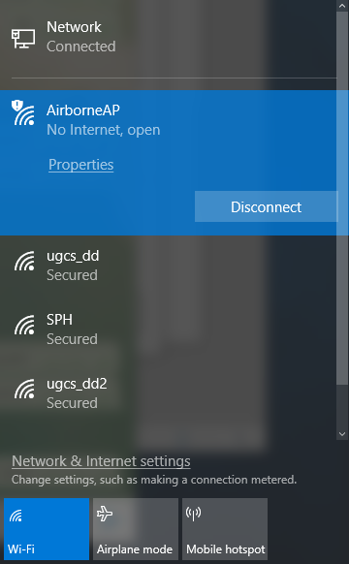

* Open browser and go to the http://192.168.10.1 page:

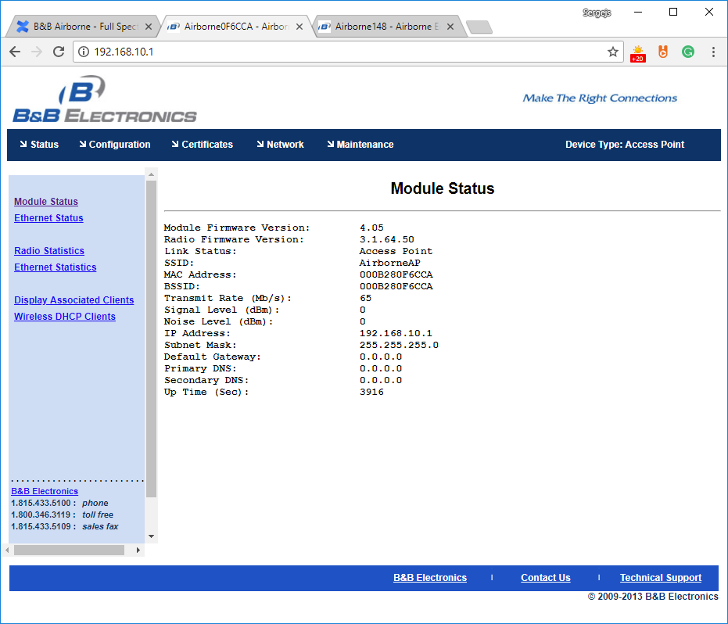

* Open the configuration page in a browser. Go to the "Configuration" → "Serial Port 2 Settings" and set:

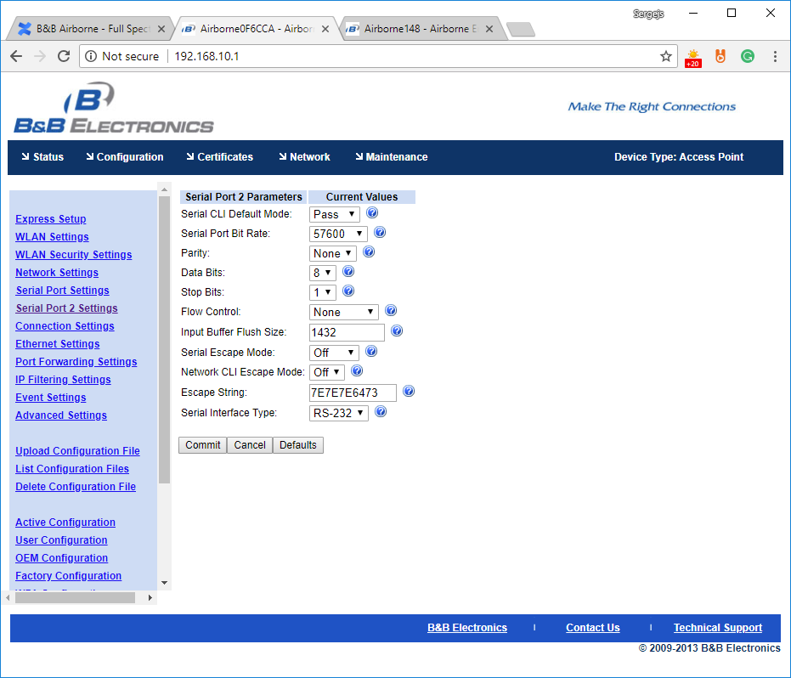

Press Commit to safe changes.

## Go to the "Configuration" → "Connection Settings" → "Common Settings" and set:

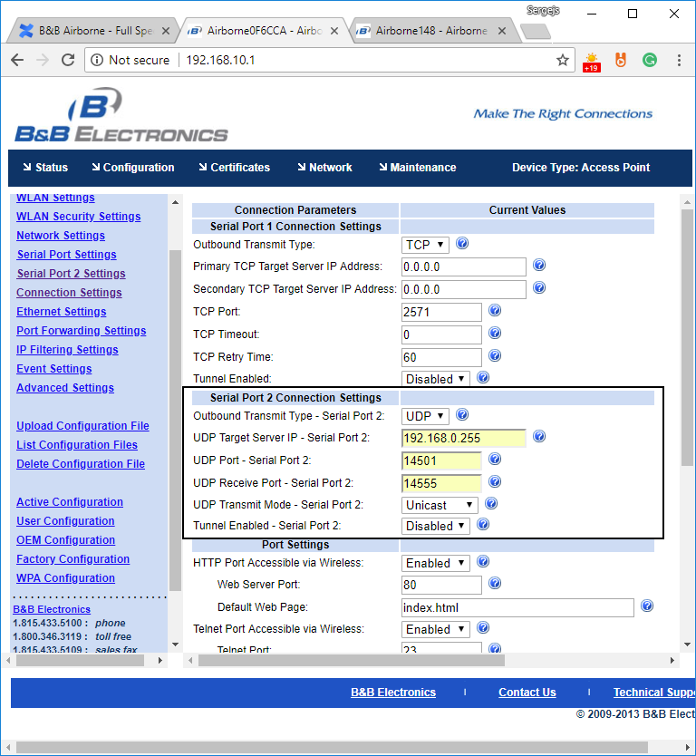

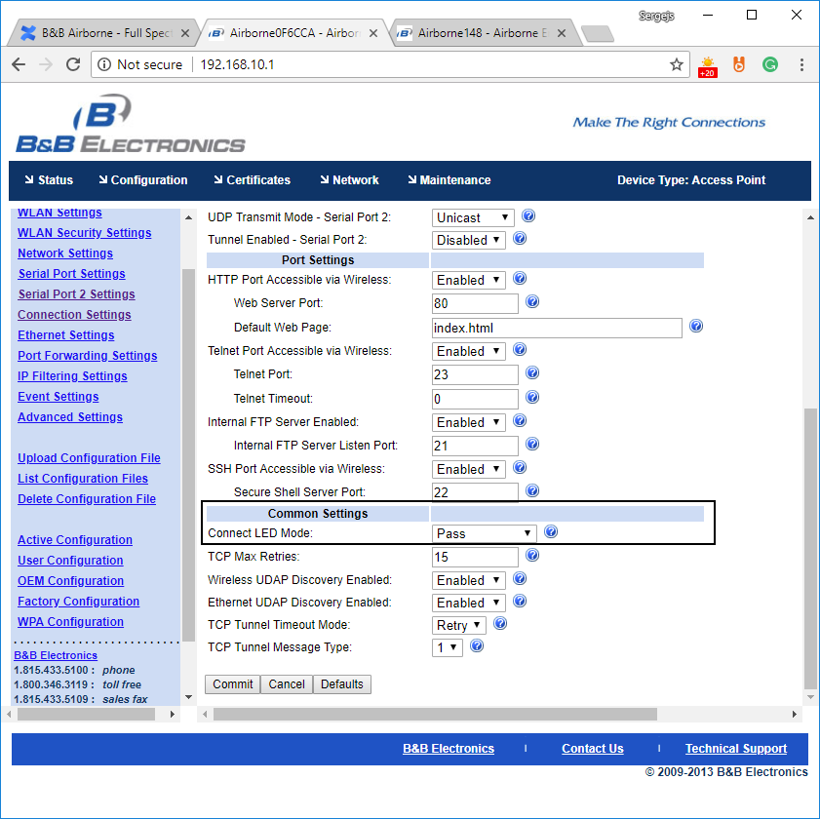

Press Commit to safe changes.

* "Configuration" → "Network Settings" and set:

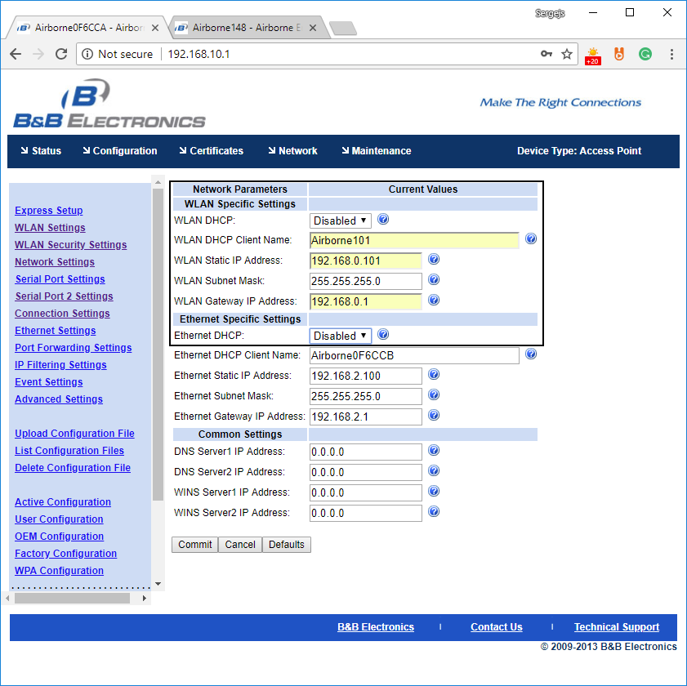

Press Commit to safe changes.

* In order to establish an AP connection we must specify SSID and password. First we have to open "Configuration" → "WLAN Settings" page. There we set:

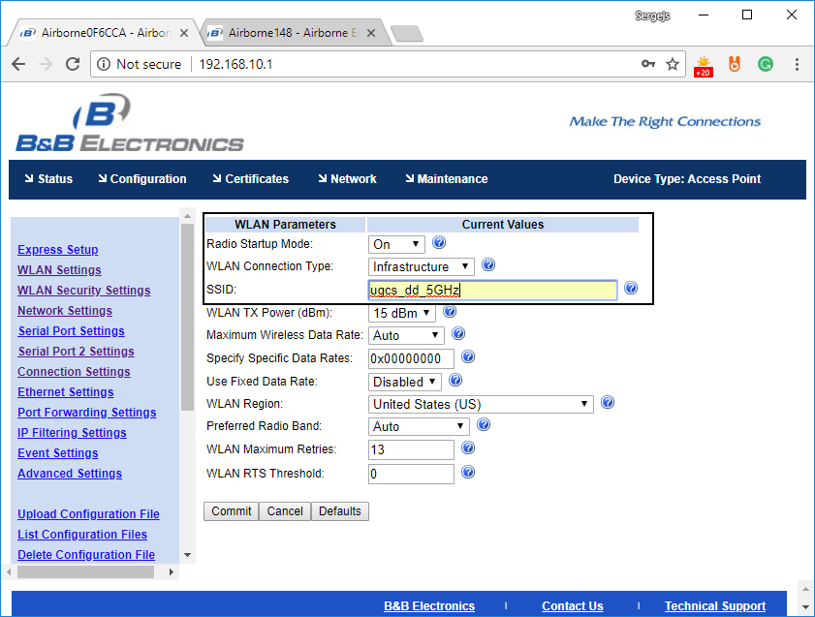

Press Commit to safe changes.

* Then on the "Configuration" → "WLAN Security Settings" page:

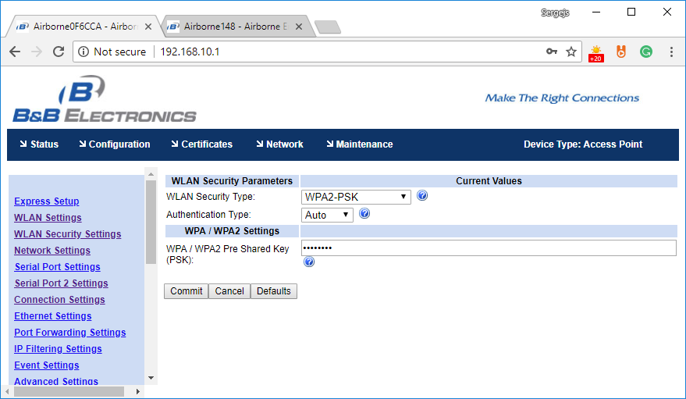

Press Commit to safe changes.

* After configuration is done, restart the Wi-Fi module.

